Descriptive Statistics Section
Frequency Table:
> attach(`Global.Temperature.Anomalies.(2)`)
> table(Hemisphere)
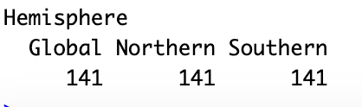

Mean:
> mean(J.D)
[1] 0.05184397

Median:
> median(J.D)
[1] -0.03

Variance:
> var(J.D)
[1] 0.1345283

Standard Deviation:
> sd(J.D)
[1] 0.3667811

Summary:
> summary(J.D)

Figure 1 Graph

> library(ggplot2)
> library(tidyr)
> library(dplyr)
>
> data <- read.csv("/Users/zoyamalik/Desktop/Global Temperature Anomalies (2).csv")
>
> data_long <- data %>%
+ pivot_longer(cols = Jan:Dec, names_to = "Month", values_to = "Anomaly")
>
> p <- ggplot(data_long, aes(x = Year, y = Anomaly, color = Hemisphere)) +
+ geom_line() +
+ facet_wrap(~Month, scales = "free_y") +
+ labs(title = "Monthly Temperature Anomalies Over Years",
+ x = "Year",
+ y = "Temperature Anomaly (°C)") +
+ theme_minimal() +
+ theme(legend.position = "bottom")
>
> print(p)

Figure 2 Graph

> data_seasonal <- data %>%
+ select(Hemisphere, Year, DJF, MAM, JJA, SON) %>%
+ pivot_longer(cols = DJF:SON, names_to = "Season", values_to = "Anomaly")
>
> ggplot(data_seasonal, aes(x = Year, y = Anomaly, color = Season)) +
+ geom_line() +
+ facet_wrap(~Hemisphere) +
+ labs(title = "Seasonal Temperature Anomalies",
+ x = "Year",
+ y = "Anomaly (°C)") +
+ theme_minimal() +
+ scale_color_brewer(palette = "Set3")

Figure 3 Box-plot

> library(ggplot2)
>
> ggplot(data_seasonal, aes(x = Season, y = Anomaly, fill = Hemisphere)) +
+ geom_boxplot() +
+ labs(title = "Box Plot of Seasonal Temperature Anomalies",
+ x = "Season",
+ y = "Anomaly (°C)") +
+ theme_minimal() +
+ scale_fill_brewer(palette = "Set1")

Box-plot Calculations
> data <- read.csv("/Users/zoyamalik/Desktop/Global Temperature Anomalies (2).csv")
>
> library(dplyr)
>
> calculate_statistics <- function(column_name, data) {
+ data %>%
+ summarise(
+ Median = median(.data[[column_name]], na.rm = TRUE),
+ IQR = IQR(.data[[column_name]], na.rm = TRUE),
+ Lower_Whisker = boxplot.stats(.data[[column_name]])$stats[1],
+ Upper_Whisker = boxplot.stats(.data[[column_name]])$stats[5],
+ Outliers = list(boxplot.stats(.data[[column_name]])$out)
+ )
+ }
>
> stats_JD <- calculate_statistics("J.D", data)
> stats_DN <- calculate_statistics("D.N", data)
> stats_DJF <- calculate_statistics("DJF", data)
> stats_MAM <- calculate_statistics("MAM", data)
> stats_JJA <- calculate_statistics("JJA", data)
> stats_SON <- calculate_statistics("SON", data)
>
> all_stats <- bind_rows(
+ JD = stats_JD,
+ DN = stats_DN,
+ DJF = stats_DJF,
+ MAM = stats_MAM,
+ JJA = stats_JJA,
+ SON = stats_SON,
+ .id = "Season"
+ )
>
> print(all_stats)

Research Question 1

> your_data_frame <- read.csv("/Users/zoyamalik/Desktop/Global Temperature Anomalies (2).csv")
>
> model <- lm(J.D ~ Year, data = your_data_frame)
>
> summary(model)
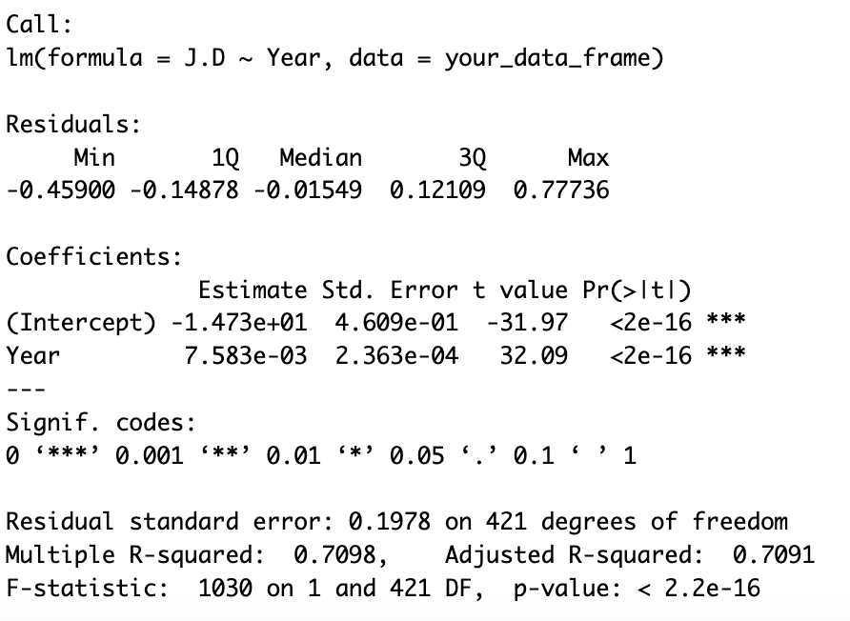
>
> new_data <- data.frame(Year = seq(2021, 2030, by=1))
> predictions <- predict(model, newdata = new_data)
>
> print(predictions)

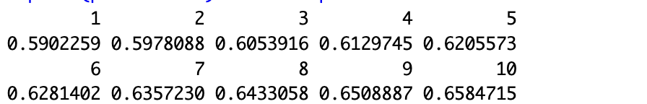

Research Question 2
> data <- read.csv("/Users/zoyamalik/Desktop/Global Temperature Anomalies (2).csv")
>
> northern_data <- data %>% filter(Hemisphere == "Northern")
> southern_data <- data %>% filter(Hemisphere == "Southern")
>
> shapiro_northern <- shapiro.test(northern_data$J.D)
> shapiro_southern <- shapiro.test(southern_data$J.D)
>

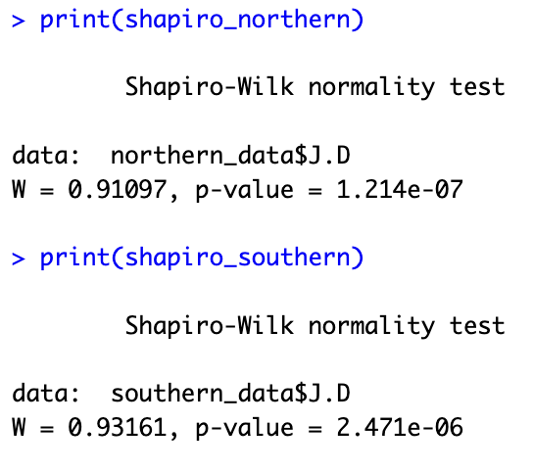

wilcox.test(northern_data$J.D, southern_data$J.D, alternative = "two.sided")
